
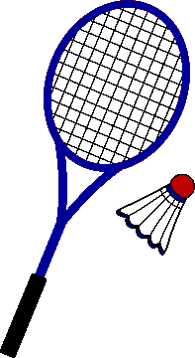
Officials in Badminton
Name:

Lesson objectives:
- To be able to identify the numerous officials needed for badminton.
- To be able to describe the roles and responsibilities of the different officials in badminton.

Name the Officials in badminton
1.
2.
3.
4.

Identify some qualities all the officials will need to be successful and why.
- Communication skills so they can clearly inform the players and the other officials if the shuttle landed in/ out etc. Voice needs to be very clear so can be heard by all.
-
-
-
-
Complete the mind map on the responsibilities of badminton officials.

Application of rules Appearance

Responsibilities

Health and safety Equipment

Officials in Badminton

Task 1: Write a paragraph describing the purpose of the officials in badminton.
Officials are needed in badminton to ………………………………………………………………..
…………………………………………………………………………………………………………………………………………………………………………………………………………………………
There are 4 main officials in badminton …………………………………………………………….
…………………………………………………………………………………………………………………………………………………………………………………………………………………………
To be a successful official, you need to have certain qualities, such as …
…………………………………………………………………………………………………………………………………………………………………………………………………………………………
because ………………………………………………………………………………………………...
……………………………………………………………………………………………………………
Task 2: Describe the role of each badminton official
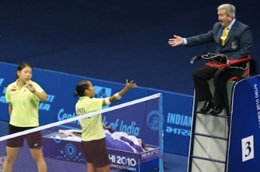
Umpire

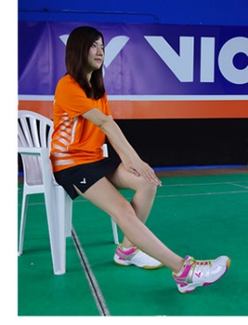
Service judge

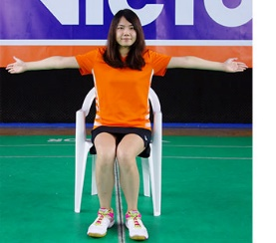
Line judge

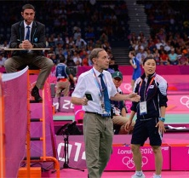
Match referee

Task 3: Explain the roles and responsibilities of ONE badminton official.
………………………………………………………………………………………………………………………………………………………………………………………………………………………………………………………………………………………………………………………………………………………………………………………………………………………………………………………………………………………………………………………………………………………………………………………………………………………………………………………………………………………………………………………………………………………………………………………………………………………………………………………………………………………………………………………………………………………………………………………………………………………………………………………………………………………………………………………………………………………………………………………………………………………………………………………………………………………………………………………………………………………………

Extension Task: Describe a specific badminton situation, and state how the official(s) will apply the rules.
……………………………………………………………………………………………………………………………………………………………………………………………………………………………………………………………………………………………………………………………………………………………………………………………………………………………………………………………………………………………………………………………………………………………………………………………………………………………………………………………………………………………………………………………………………………………………………………………………………………………………………………………………………………………………………………………………………………………………………………………………………………………………………………………………………………………………………………………………

